An RFS Innovation or a washing of hands? POSTSCRIPT
11pm, 13 Nov 2019

Unintended consequences
Last night’s 7.30 Report interviewed a lady who felt she had to get out. She had a blown-up copy of the RFS map of fire spread for Tuesday’s catastrophe day. Look right here, she said, here is my house in the middle of the red area, I have to go now.

I presume this was the ultimate aim of RFS. Well meaning, I suppose. Get everybody out of harm’s way. Most will go because they trust the authorities’ judgement. Perhaps they understand that people like me, who are able to assess the danger more professionally and make an informed decision about self-defence capability in safety, are few and far between. It is a learned skill like swimming or driving a car. I would like all Australians to learn it because it is in our DNA to overcome danger, not to put up with it or run from it year after year, like we are doing now. Overcoming ignorance and fear about bushfires will rid us of the bushfire menace for good, whatever our climate.

The problem with evacuating everybody from the estimated path of a bushfire is what research has been telling us for decades, including Victoria’s Black Saturday. The house loss rate of vacant undefended houses in a severe bushfire attack is very high, up to 90%. Evacuation saves the life, but loses the house. It is important to focus on saving the house. Why? Because saving the house also saves the life, and saving life is our first priority. We can and must save both. People hate losing their homes.

The problem with evacuating everybody as a first response is that it should be a last resort. The RFS employs one main protection measure = suppression. They are virtually saying to us – get out now, we cannot help you with our one protection measure. But if they invest in effective prevention options and prepare us and our surrounds properly, we can stay put and self-defend against ember attack. When they realise that severe bushfire attack is typically mass ember attack over multiple houses simultaneously, they will understand why evacuation causes mass house loss. Mass house ignition by tiny spot fires needs all hands-on-deck, then and there, to swat them out. A few fire trucks and some aircraft might save a few houses, but where are the residents’ hands to save the rest?

The problem with branding areas in red danger is that insurers will come to realise the RFS cannot protect houses in bushfire areas. This leads insurers to increase the premiums, which people cannot afford. On the other hand, the payouts are an investment boost in the local economy. What is more important to people – avoid personal distress or stimulate local GDP?

The problem with exaggerating bushfire risk due to climate change or whatever other reason, is that it inspires the insurers to raise premiums multi-fold. One guy who lost everything was uninsured. He said today his area was recently rezoned at higher bushfire risk, and insurers put up the annual premiums from $1000 to $4000. They would not accept quarterly payments. He couldn’t pay it. The current interpretation of bushfire risk by authorities is unfairly incorrect. It needs urgent review. I suggest we all take a chill pill about climate change and bushfire danger so we do not inspire the insurers to charge more for a prediction. Make sure they work with facts. The weather bureau’s record with a 7 day forecast is sometimes correct. We can check these. We can’t check a 20- or 30-year prediction.

What happened on Tuesday in the red areas?

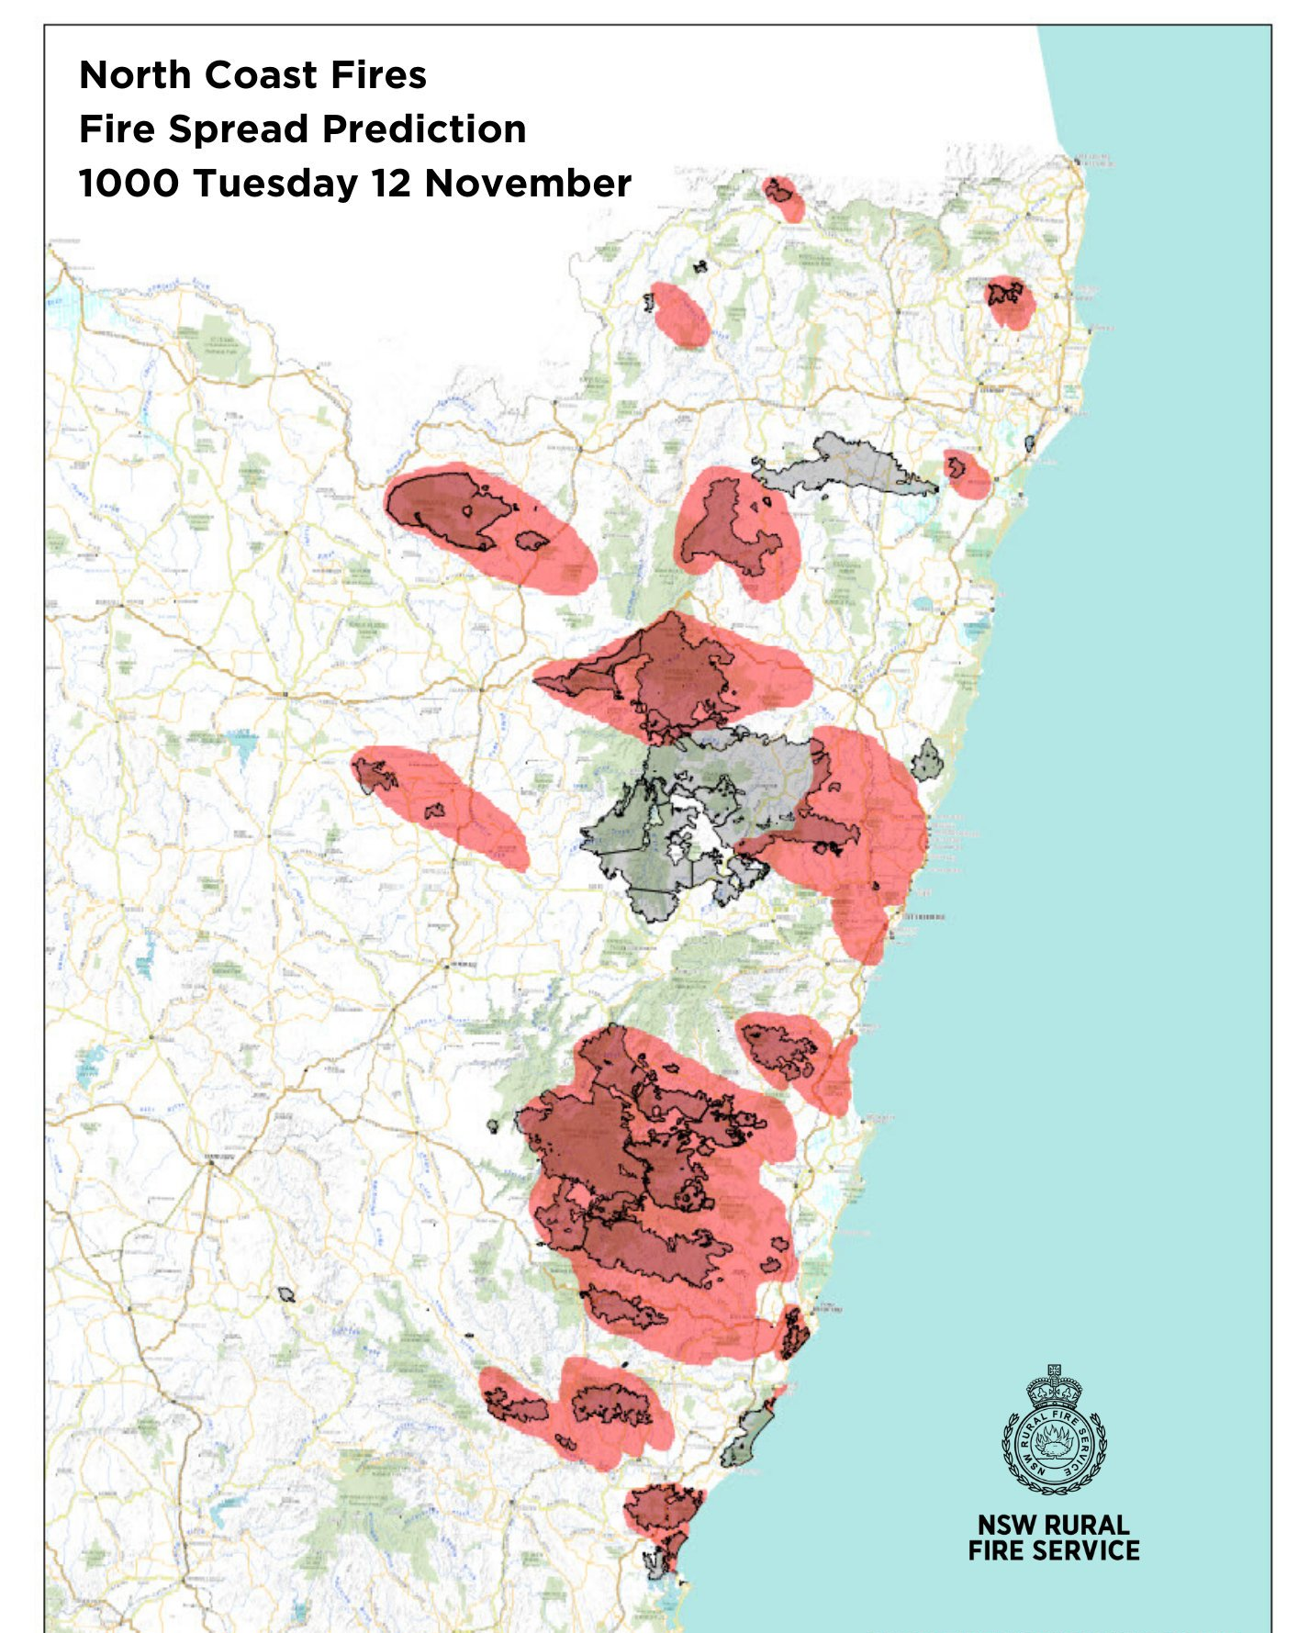

I compared the RFS 10am prediction map with this morning’s RFS fire map on “Fires near me” and marked a blue arrow wherever fire expansions occurred.
- There are thirteen arrows.
- They are all narrow tongues that spread a relatively minor distance, compared to the red expanses.
- The combined area increase is barely 1% of the downwind red area.
- Some large fire areas did not grow at all
- There are no new fire areas with fresh runs

Conclusions
The red danger prediction was a bit too exaggerated for credibility.
If the RFS wants to extinguish fires in severe fire weather it can and does. [I hear most if not all the large burnt blocks were the result of letting the fires run a bit too far two months earlier.]

Was the weather as bad as predicted?

The RFS map covers Foster and northwards. The weather here is relatively benign compared with Sydney and the Hunter.

Taree is an indicator of the coastal areas:
- Before 10am, winds are light (<10kph) and variable direction. Humidity high (> 40%)
- From 10 to 1pm, winds are from W and WSW and WNW up to 20kph. Air drier in the low teen %. Temperature low 30’s.
- From 1pm to 7pm, winds are from NE and ENE 20 – 30 kph falling to 10kph, Humidity rising from 15 to 40% . Temperature low 30’s falling to mid 20’s.

Worse fire weather is in the Sydney and Hunter areas, which are outside the RFS map.

Indicator is Cessnock
- Before 8.30am, winds are light (<10kph) and variable direction. Humidity high (> 30%)
- From 8.30am to 8.30pm, winds are from NW, @ 30 - 35kph till 4.30pm then drop to 20 kph, RH very low 5 – 8% for most of day, temp > 35 for most of day. Peak FDI 70 – 80
- After 8.30pm till 11pm, winds are from WSW blowing at 30kph and after a few hours falling to 20kph. Temperature falling from 30 to 20C.

