Busbys Flat Bushfire 2019 / 2020 Fire Season

Initial fire area - 4 October = <10 ha

Red diamond marks origin. Size at detection is unknown.

Fire expansion by burn-out - 4 to 7 October
4 to 7 October Firefighters burn out 600ha = red outline (approx 6 x 1 km)
7 October - Evening Spot fire escape at red arrow

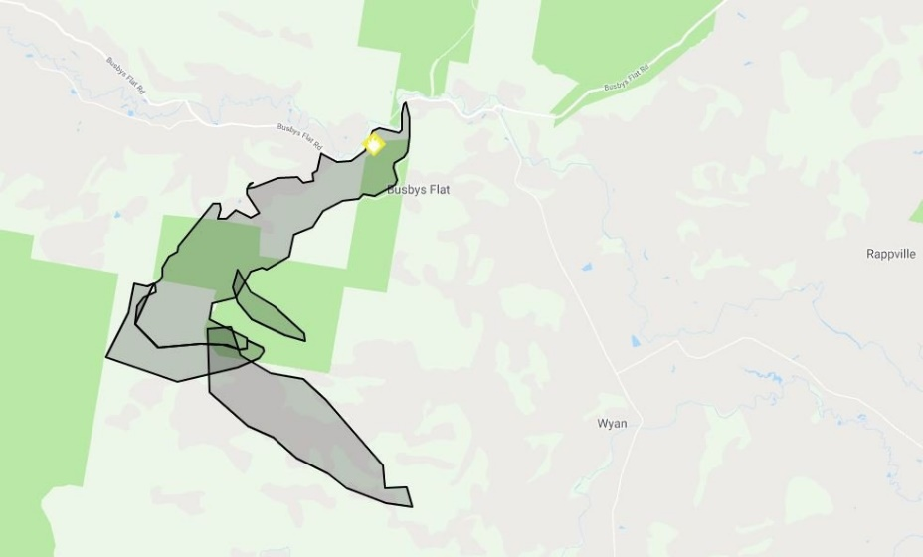

Blow up day – 8 October

Deduced wind directions on fireground today:
From 12am to 9 / 10am 12 / 1pm - Light wind from NW
From 9 / 10am to 12 / 1pm - strong wind from NW
From 12 / 1pm to approx 6pm - strong wind from W
From 6 - 6.30pm into tomorrow - Strong wind from S

Fire perimeter at midday, just before W winds begin. The 5km escaped-tongue to the SE has created a boomerang shaped fire front of 8km width in readiness for the W wind change.

Fire perimeter at 6pm

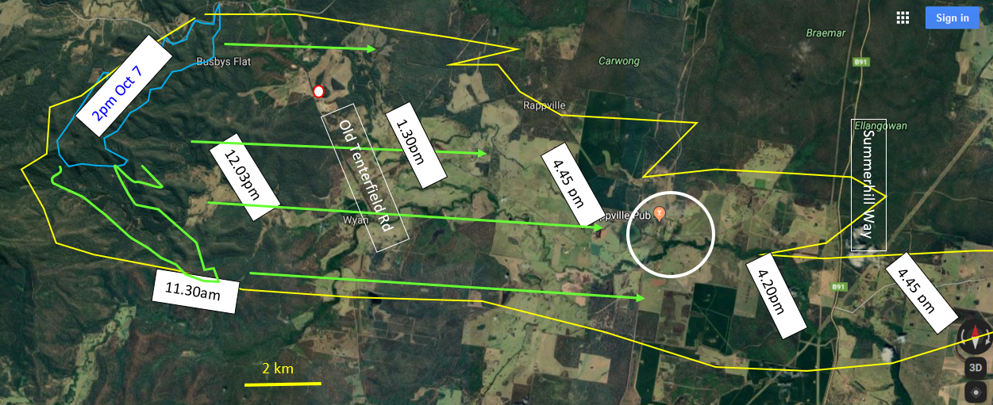
White circle = Rappville township, Red / white circle = sawmill,
Fire behaviour symbols: Blue line = fire edge Oct 7, green line = fire edge 11.30am on 8 Oct, yellow line = fire edge at approx 6pm Oct 8.
Green arrow = indicative pathway of separate tandem fire fronts. Time stamps = fire front site
Time tags are based on times reported in media.

The RFS said 44 homes were destroyed by the Busbys Flat blaze.

Current size Mid November > 30,000 ha

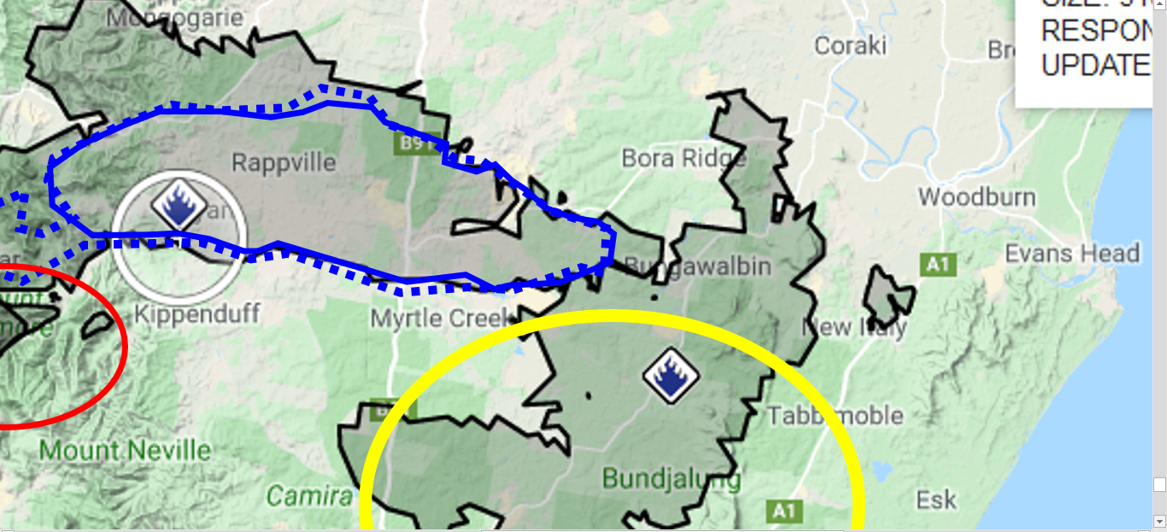
Blue line is Busby fire perimeter on October 9.
Yellow circle expansion is very recent. Not yet determined if it is an extension of Busbys Flat fire.

Conclusion
If a public poll had been taken the night of the 4th October on this question - Do we keep the fire at 10 ha or do we burn it out to the tracks? What would be the response?
If a public poll had been taken the night before the 8th October on this question - Do we keep the fire at 600 ha or do we let it run and catch it in the paddocks? What would be the response?

The point is this. It does not matter what the people with destroyed property think about bushfire suppression strategies. The outcome is what matters. This outcome is disastrous because it is avoidable. The initial fire should have been kept small on the 4th. But it was not. The escaped spot fire should have been stopped before the 8th. But it was not. The 6 km eastern boundary of the burn-out fire also escaped. They should have prevented that as well. They should have thought of these things before they lit up the 600ha. But they evidently did not.

RFS seems to tolerate uncontrolled perimeters in forest areas but at the same time warns the public to enact their plans when each severe weather day is forecast.
Their apparent policy of letting fires burn the forests into the summer months is risking property loss. [Is this done with or without approval of forest managers?]
- If the rains come before the next severe weather day, risk is forgiven.
- Every day the rains are delayed, the drier the drought, the worse the outcome when each next severe weather day comes.

This seems a high-risk strategy for unprepared rural houses because the fire agencies well know their capacity to protect assets and suppress severe weather bushfires is very limited. But if forewarned about their strategy, rural properties can prepare themselves for self-defence and defeat the bushfire threat.

In this level of severe bushfire attack, the fire agency is virtually helpless, despite a massive force of 74,000 volunteers and massive budget. The latest published house loss rate for the current RFS policy model this fire season is around 20%. It is much lower than the house loss rate under the then CFA policy model in the Black Saturday fires of Victoria in 2009
(average 39%, range by fire 14 – 60%, but individual towns were higher, eg, Marysville 90%).

This leads into my theory that self-defence can complement suppression and save houses.
If each property and settlement were prepared at base level 101 for a severe bushfire attack and occupants prepared for active self-defence, the danger flames would be kept well away, the people would safely extinguish the small spot fires, the fire attack wave would come and go like a hail storm and they would resume their interrupted activities.

This did not happen here because there is no catalyst to make it happen. The fire agencies have their policies and procedures but they do not include organising the local properties for self-defence. They do however include disaster-response policies like trust us and obey our instructions if a fire occurs. Their instructions are typically evacuation related, a strategy that can exacerbate house loss rate. At the same time, fire agencies are aware their capability to protect houses in unprepared surroundings under severe bushfire attack is more a hope than a reality. Meanwhile, individual property owners are not encouraged by any authority to consider self-defence as an option. The missing catalyst is a government level goal of zero house loss in severe bushfire attack. Indeed, a towards zero goal would be useful. That would re-focus the fire agency policies and procedures and encourage property owner focus on preparedness and self-reliance.

