Emergency Messages may be of Questionable Benefit

Denis O’Bryan
Red Eagle Bushfire Protection Services
4 January, 2020 (5.30pm)

There are currently multiple emergency warnings on the Victorian Emergency Services map at 4.30pm today. They concern extreme fire behaviour. Even though it is a declared Disaster area, I fear they may overstate the danger and incite panic.

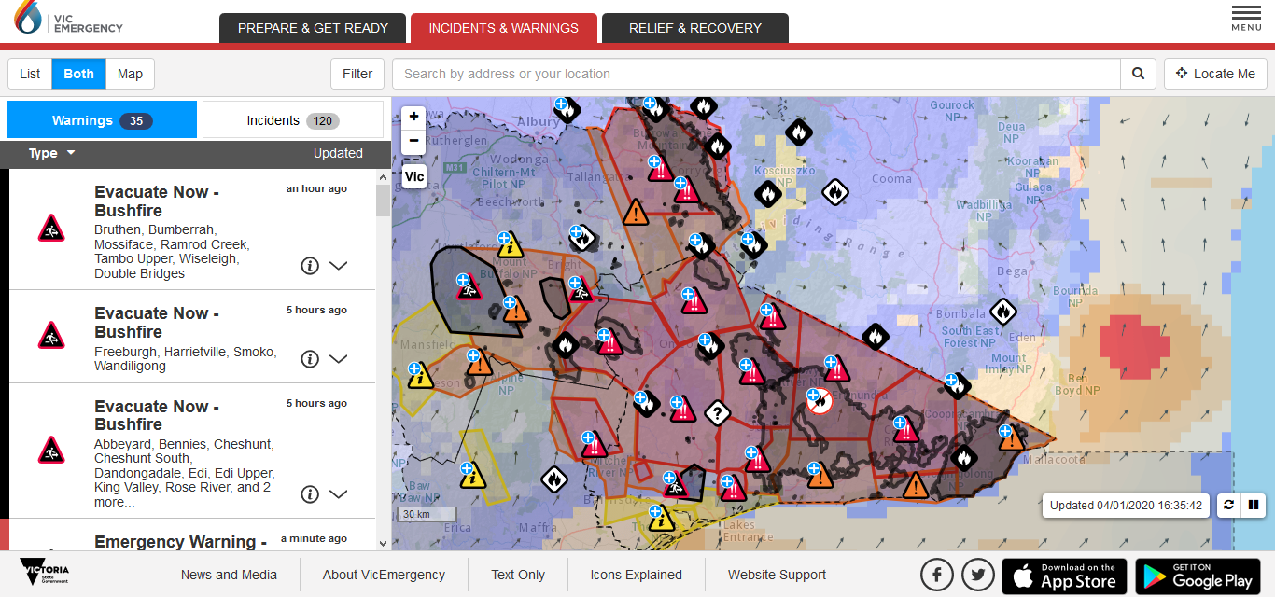

Look at the Bruthen warning issued a few minutes ago:

The SSW winds arrived there at midday.
The current weather does not even reach ZERO on my Fire Danger Index scale

Station Details | ID: 084144 | Name: MOUNT NOWA NOWA | Lat: -37.69 | Lon: 148.09 | Height: 350.0 m
Data from the previous 72 hours. | See also: Recent months at Mount Nowa Nowa
Date/Time  EDT | Temp  °C | App  Temp  °C | Dew  Point  °C | Rel  Hum  % | Delta-T  °C | Wind |  |  |  |  | Press  QNH  hPa | Press  MSL  hPa | Rain since  9am  mm
 |  |  |  |  |  | Dir | Spd  km/h | Gust  km/h | Spd  kts | Gust  kts
04/04:30pm | 18.1 | 16.8 | 14.8 | 81 | 1.9 | SSW | 15 | 32 | 8 | 17 | - | - | 0.0
04/04:00pm | 18.5 | 17.4 | 15.2 | 81 | 2.0 | SSW | 15 | 35 | 8 | 19 | - | - | 0.0
04/03:30pm | 19.5 | 18.2 | 14.7 | 74 | 2.8 | SSW | 15 | 33 | 8 | 18 | - | - | 0.0
04/03:00pm | 20.6 | 18.4 | 14.3 | 67 | 3.7 | SSW | 19 | 41 | 10 | 22 | - | - | 0.0
04/02:30pm | 23.6 | 21.7 | 14.3 | 56 | 5.6 | SSW | 17 | 35 | 9 | 19 | - | - | 0.0
04/02:00pm | 25.5 | 22.8 | 13.4 | 47 | 7.2 | SSW | 20 | 37 | 11 | 20 | - | - | 0.0
04/01:30pm | 26.7 | 22.9 | 12.4 | 41 | 8.4 | SW | 24 | 46 | 13 | 25 | - | - | 0.0
04/01:29pm | 26.7 | 22.8 | 12.0 | 40 | 8.6 | SSW | 24 | 46 | 13 | 25 | - | - | 0.0
04/01:00pm | 31.7 | 27.8 | 9.3 | 25 | 12.8 | SW | 20 | 43 | 11 | 23 | - | - | 0.0
04/12:30pm | 35.7 | 29.8 | 7.7 | 18 | 15.9 | WSW | 28 | 56 | 15 | 30 | - | - | 0.0
04/12:27pm | 33.4 | 27.5 | 7.4 | 20 | 14.5 | WSW | 28 | 56 | 15 | 30 | - | - | 0.0
04/12:00pm | 33.5 | 29.5 | 8.9 | 22 | 14.1 | WSW | 20 | 39 | 11 | 21 | - | - | 0.0

The nearest fire does not even appear on this map, by the way.

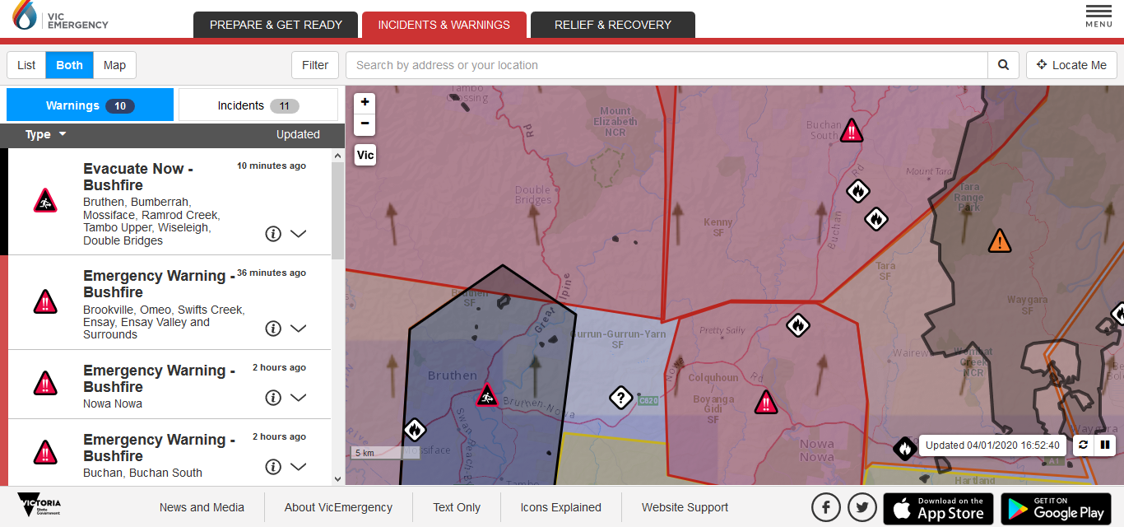

This message about extreme fire behaviour is inconsistent with the current fire danger level.

Now look at the NE where fire danger is still high.
Let’s look at the Koetong warning issued 32 minutes ago.

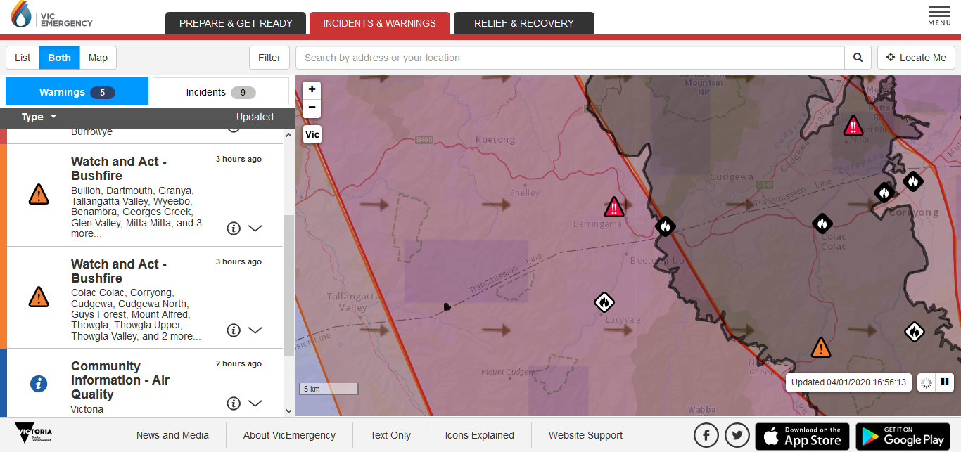

The going fire is to the west of Koetong.
The wind has been from the west since 11am.
FDI is currently 50, but the fire poses no danger to Koetong and will continue as such if a SW change occurs.

Station Details | ID: 082139 | Name: HUNTERS HILL | Lat: -36.21 | Lon: 147.54 | Height: 981.0 m
Data from the previous 72 hours. | See also: Recent months at Hunters Hill
Date/Time  EDT | Temp  °C | App  Temp  °C | Dew  Point  °C | Rel  Hum  % | Delta-T  °C | Wind |  |  |  |  | Press  QNH  hPa | Press  MSL  hPa | Rain since  9am  mm
 |  |  |  |  |  | Dir | Spd  km/h | Gust  km/h | Spd  kts | Gust  kts
04/04:30pm | 38.4 | 32.6 | 0.0 | 9 | 20.2 | W | 20 | 56 | 11 | 30 | - | - | 0.0
04/04:00pm | 37.4 | 31.1 | -0.8 | 9 | 19.7 | W | 22 | 46 | 12 | 25 | - | - | 0.0
04/03:30pm | 37.7 | 31.5 | -0.6 | 9 | 19.9 | WNW | 22 | 48 | 12 | 26 | - | - | 0.0
04/03:00pm | 37.2 | 30.3 | -2.5 | 8 | 20.0 | WNW | 24 | 43 | 13 | 23 | - | - | 0.0
04/02:30pm | 37.3 | 31.0 | -0.9 | 9 | 19.7 | WNW | 22 | 43 | 12 | 23 | - | - | 0.0
04/02:00pm | 36.4 | 31.9 | -0.1 | 10 | 19.0 | WNW | 13 | 28 | 7 | 15 | - | - | 0.0

This warning requires people to stay indoors – too late to leave.

A death-threatening message like this one today for Koetong seems a bit unnecessary:
You are in danger and need to act immediately to survive.

And what action should they take?

This message today for Koetong is incorrect. Koetong is on the upwind side of the fire.

Discussion
It seems the graphic evacuation messages of yesterday evening with words like fire storms, possibility of death and road closure that prevent movement have now been replaced by “stay at home”.

I suggest the government should not be giving life or death advice / house loss or saving advice. Ever. Finance advisers are convicted for giving general advice about people’s money, and here is government giving general advice about potential survival of their houses and lives.

It is a potential legal minefield. Government has not given them full information about the consequences of evacuation nor has it sought to determine relevant information about their property. Eg, If people accept government advice to evacuate and their house burns down even though it was safe to stay and defend, government has erred. If people do not accept advice because they think the wolf has cried too much, and their house burns down, government has also erred. Government immunity may apply, but there is huge potential for the damage toll to be exacerbated.

Besides, in a few hours these emergency messages will be replaced by Watch and Act. And life goes on till the next severe weather day. I am not convinced this type of blunt emergency messaging is helpful.

On the other hand, the combination of frequently updated fire area maps and wind direction as on the EM website are excellent resources, perhaps sufficient for people to help determine their own course of action.

