Mallacoota unprepared – supplementary evidence of bushfire severity

Denis O’Bryan
Red Eagle Bushfire Services
4 Feb 2020

Thanks to an article in the New York Times written by Livia Albeck-Ripka on 14 January, 2020, I can present some more images that support my assessment that the bushfire attack on Mallacoota was at the lower severity level. https://www.nytimes.com/2020/01/14/world/australia/fires-mallacoota.html
This is the type of panorama aerial I was hoping to find.
It is taken as the plane descended to the airport after the fire. It looks along the coastline to the NNE, which is the direction the wind (the wind oscillated between SW and SSW) pushed the fire fronts on the morning of 31 December 2019 towards Mallacoota, which is beyond the airport in this picture.

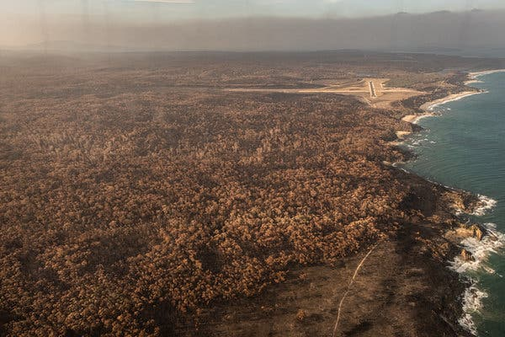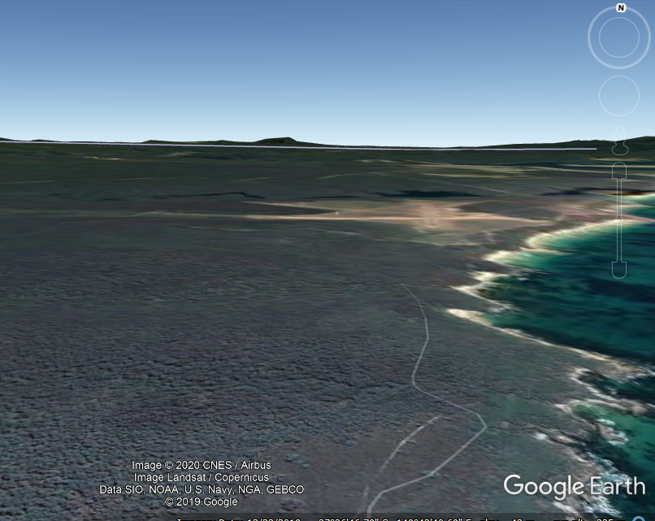
Burned forest near Mallacoota on Saturday (11th Jan)
AFTER BEFORE
Where are we? Mallacoota airport is here, Mallacoota town is here
The keen eye of the forest fire professional notices the sea of brown tree top puffs in the aerial. They have a story to tell:

The flame on the ground beneath them was hot enough to kill the leaves but the flame height was too low to burn them. The trees here are low, most probably less than 10m tall. We can expect there was an undergrowth layer of coastal heath flora up 1 to 2m tall. This means the flames were barely taller than this layer. Low flames mean low severity bushfire attack.

Low flame means weak ember uplift speed from flame on ground into the wind above the tree tops, and this means short throw distance downwind. This all means ember attack is short distance (eg, most within 50m ahead of source flame) and low density (eg, tens per sq m, compared to hundreds or thousands in a severe attack).

We also notice dark patches amongst the brown sea. They are unburnt crowns. We cannot see black patches with vertical sticks, meaning burnt crown areas. I expected to see some in areas of locally dense / tall undergrowth. The area of low treeless heath shown in blue dash outline was totally consumed.

The extent and uniformity of the burnt area is breathtaking. The photograph distance at the airport-horizontal is approx 3km. Did it burn as a single wide front or as multiple parallel fronts in tandem?

Uniformity of the colour range in the burnt area indicates consistent range of flame behaviour throughout. (Don’t worry if this statement does not make sense)

1 km
White arrow is view from plane towards airport

No doubt, Livia faithfully reported what she was told by the authorities:
“But this year, as one decade gave way to another, a fierce inferno swept through the community, destroying homes and severing power lines”.

But the evidence in her article tells a different story. I present some photos below where you can see unburnt shrubs and green tree crowns within Mallacoota and masses of the tell-tale brown scorch of short tree canopies. These are indicators of low severity bushfires. Low severity bushfires are what we want close to our towns.

Livia included some excellent photos showing post-fire vegetation around Mallacoota, but we have to point out that the Wiseleigh tree lopping photos in her article are actually near Bruthen, 150km to the west.

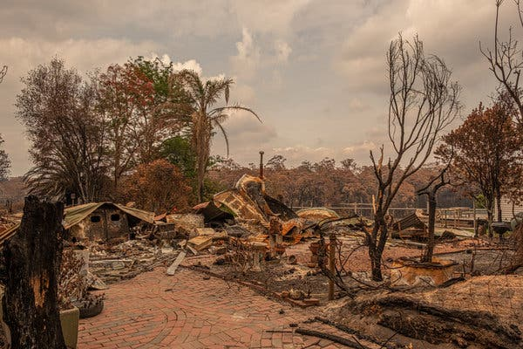
Note the line of scorched low forest canopy in the adjacent forest in the background
Note the greenery near the house site.
Note the scorched shrub, indicating very low flame
Be aware that the heat and flame from the house fire probably burnt the foliage off the close trees and shrubs.

One of the many properties in Mallacoota destroyed by bushfires.

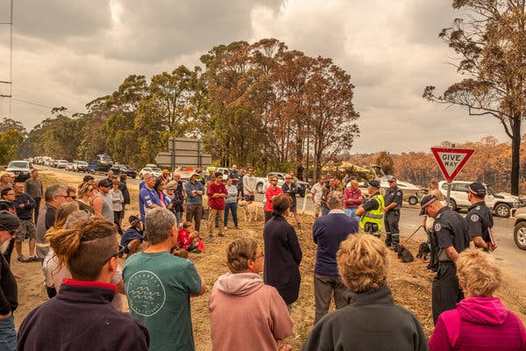
A briefing Sunday for people who were part of the first convoy to leave Mallacoota, after the military cleared some roads north of town.

Note the line of scorched low forest canopy in the adjacent forest.
Note the taller unburnt roadside trees.
Note that some were scorched by a localised low flame beneath.

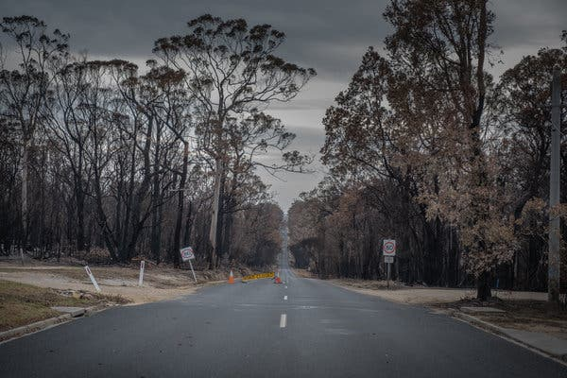
The road into Mallacoota.

Note the adjacent forest canopy is scorched. I suspect the tallest foliage is unburnt. Note how close to the ground the scorched leaves are.
Note the bark of most trunks appears blackened because the loose outer bark has been burnt off. The white gum bark remains unburnt.
Note the extensive unburnt grass patches, gravel and bitumen. Is there a lesson in that for all of us?

