Minimbah / Tuncurry Bushfire 2019 / 2020 Fire Season

Initial fire area - 18 October = 1,600 ha approx

Red area has been burning for at least a week before 26th within Minimbah National Park.

Blow up day = 26 October
Expansion on 26th is multi directional.
Red area has been burning for at least a week before 26th.
Green expansion occurred on 25th.
Blue expansion occurred on 26th - 11.30 to 3.45pm towards SE, 3.45 to 4.45pm towards E, 4.45 to 8.30pm, towards S / SE, 8.30 – 11.30pm, towards N / NW.

Taree weather on 26 October:
Before 11.30 am 20 – 30C, 30%+ RH, winds from E / ENE @ < 10kph
11.30 am to 3.45pm 35C, 14% RH, winds from NW / WNW @ 30 – 40 kph
3.45 to 4.45 pm 30C, 25% RH, winds from WSW to WNW @ 30 - 40 kph
4.45 to 8.30 pm 20 – 25C, 30 – 35% RH, winds from N / NW @ 10 – 20kph
8.30 – 11.30 pm 20 – 25C, 35 – 60% RH, winds from S / SSE @ 15 – 25kph

Final size Mid November 4,400 ha

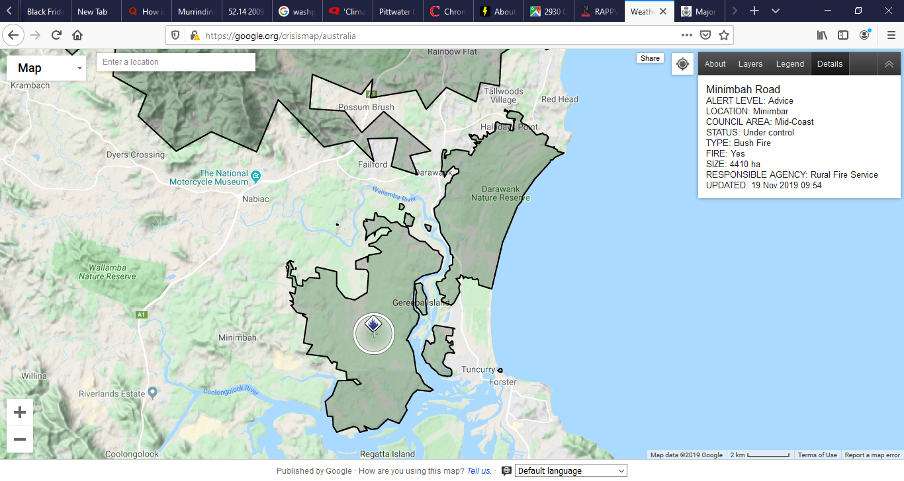
Red outline is original fire size on 18 October

Conclusion
The Minimbah fire caused a lot of people in Tuncurry and surrounds a lot of unnecessary anxiety and disruption. The firefighter decision to enlarge the fire that caused it was not well thought out. Creating a large very fresh burn (8km wide exposure that is 2km deep) in a semi dry swamp, in peak of the dry season, too km upwind from Tuncurry, a few days before strong winds, are ingredients for a risky outcome. The escape of the Darawank spot fires suggests incomplete blacking out or under-resourced suppression. Luckily there was relatively low house loss for both fires.

The fact that these fires escaped shows misunderstanding of at least one aspect of forest fire behaviour in the height of a dry season / drought. The fire controller made the same error during the Suppression Creek / Wye River suppression – when forest fuel is bone dry, trees and stumps smoulder for days as hot spots. They reinvigorate in wind and they reinvigorate again at each wind direction change.

Curious to know if National Parks approve these burn offs to extend burn area, or if it is RFS’s call.

The messages from RFS to the people are interesting. They are quite matter of fact and adult compared to Victoria’s generalised nanny state messages (eg, leave home early this morning and go to a big city shopping centre all day), and sometimes inane messages (it is too late to leave, seek shelter in an open paddock). Here is a selection:

Bushfire survival plan:
People are expected to have a plan of survival and to know what to do. The Victorian plan is a pseudonym for an evacuation plan. I hope the NSW one is more protective of the property.
- Discuss fire survival plan tonight and know what your household will do if threatened by fire
- Residents should enact their bush fire survival plans
- If your plan is to leave, leave early before the fire threatens
- Residents in this area should take shelter as the fire approaches
- Stay alert for burning embers and spot fires. Seek shelter if the fire impacts on your property.
- If you're in the area, watch out for spot fires.
- Residents should be aware that falling embers may create spot fires and threaten properties.
- It is now too late to leave. Seek shelter if the fire impacts on your property
- Residents in the area should continue to monitor conditions & know what they'll do if fire threatens
Instructive:
- This video shows the danger of ember attack, even if you're a few streets back
Backburns:
- People in the area will notice an increase of smoke and fire activity as these burns are undertaken.
- Firefighters have been working to contain the fire burning in wet lands within the Minimbah National Park. This fire is likely to remain visible to surrounding areas for some days. Smoke will settle in areas locally overnight.

