Self-defence of Batlow and Bawley Point

Denis O’Bryan
Red Eagle Bushfire Protection Services
9 January 2020

The benefits of self-defence during bushfires flow when preparations are done and people power fights back. The damage toll is high when preparations are not done and worried fire agencies evacuate residents and deploy inadequate resources to prevent losses in vacant houses.

Imagine if the towns Victoria and NSW had been pre-prepared before this fire season with strategic fuel-free and low fuel areas and the people had been trained in what type of ember attack to expect and how to extinguish spot fires when small. There would be no calls for evacuation of tourists or locals and no mass panic and fear, and no TV cameras interviewing distressed locals. The locals would be professionally extinguishing spot fires on their properties and their neighbour’s, the fire brigades and town protection teams would be attending where spot fires were unattended and the TV cameras would be interviewing jubilant locals, thrilled that they beat the bushfire enemy with knowledge and skill. All the people’s assets and valuables would be safe and intact and the commerce of the town would continue next day as if nothing happened.

Here are a couple of towns in NSW that were well on the way to achieve bushfire protection capability - one by force of determination of locals and the other due to a local landowner’s foresight. I have not found any yet that were pre-prepared as part of a formal fire agency HQ program, but would like to know about them.

Batlow
I saw two interviews on Sky News during the plane trip to Brisbane on Monday AM. It was about Batlow.
They interviewed a local fire agency chief. He said - We expected big losses
They interviewed a Batlow Trader. He said – We knew we were defendable. We all pulled together and had few house losses.

I thought – hello, do these disparate viewpoints signal a disconnect between what the town wants (defendability and few house losses) and what the fire agency delivers (house loss is inevitable collateral damage)?

I later found a couple of relevant articles by David Crowe of the SMH.

Defending the 'undefendable': How Batlow was saved
The town of Batlow was meant to be "undefendable", but the local Rural Fire Service had its own ideas. January 7, 2020 by David Crowe

The people of Batlow were told their town was "undefendable" when a bushfire raced toward them last Friday, but the local Rural Fire Service brigade had other ideas. "On the Friday there was an evacuation order in place and the last thing the RFS wants is 67-year-old blokes with a garden hose trying to save a house," a local orchardist says.

The southern NSW town is now charred by flames that destroyed the old hospital, blew up the petrol station and burnt 17 houses in town and an untold number of outlying properties. But the members of the Batlow brigade know it could have been much worse. "We didn't lose any lives, that's the main thing," says Brian Droscher, the equipment officer in the local brigade. "And we saved houses. We had a big fight but it was worth it."

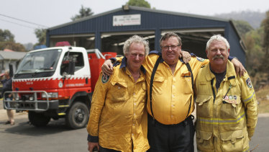
Batlow volunteer firefighters Jeff Kynaston, Darryl Watkins (captain) and Brian Droscher who stayed to fight fires impacting Batlow the previous Saturday.Credit:Alex Ellinghausen

The brigade had to fight the fire with the help of local farmers and workers that deputy captain of the Batlow brigade Jeff Kynaston called the "slip-on brigade" – those who were not trained to hold a fire hose but helped in any way they could. Did he think the town could be saved? "I didn't think we could be saved," he says. Yet the brigade and their helpers not only saved themselves but also prevented far greater damage to their town. "Everyone thought it was gone," says Kynaston. "I can't believe the number of homes that were saved."

The fight to save Batlow's 99-year-old pub
Matthew Rudd stayed behind in Batlow to stop raging bushfires from destroying his pub, which turns 100 this year. January 7, 2020 by David Crowe

Batlow Hotel owners Linda and Matthew Rudd, who are remaining open to feed firefighters and residents.Credit:Alex Ellinghausen

Rudd stayed behind to save their hotel, which is almost a century old. About 60 others stayed in town. Within hours, they were watching a bushfire sweep over the hills and burn through the town.

"You could hear the crackle of the fire coming through and you knew it was coming fast. It only crowned a couple of times through the trees but you could still hear it coming quickly. Before you knew it, all down here was on fire beside the service station. I got on the radio and they said 'we don't have anybody' – they didn't get the resources they asked for.

"So I put out a few spot fires as they were coming up towards the pub. I've got a couple of fire reels at the pub so I was using one of those. The visibility was half-decent, it wasn't too bad – it wasn't until the fire went out that the smoke came in and made it really hard to see."

Rudd said people were everywhere trying to do what they could. "Some stayed in their houses. Most were out and about trying to do what they could," he said. "I was always quietly confident that it was going to be OK. I just kept wetting down any areas that might catch fire. There are gable ends and timber. There were spot fires in the back of all the yards here and a few times I had to use buckets because there was no water to put things out.

"The pub turns 100 this year. I didn't want to get out for 99."

How defendable is Batlow
I have done a basic desktop analysis.

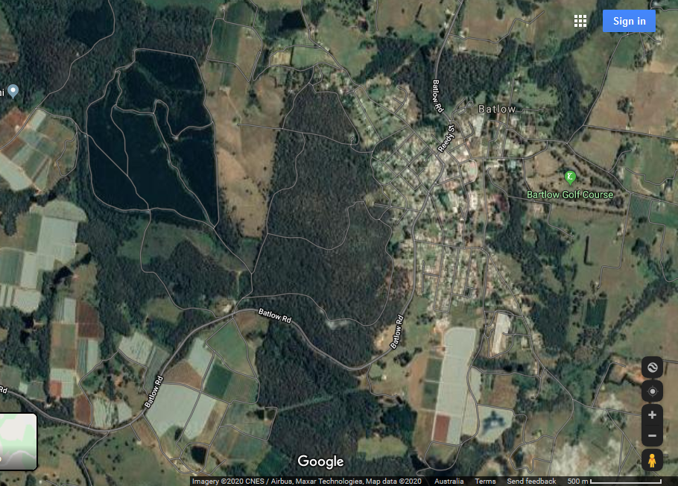
The fuel bed within the town is what we call discontinuous, meaning there will be no running flame. If a spot fire ignites, it remains a stationary flame, ie, it cannot run very far till it hits a fuel-free barrier and self-extinguishes.

The block of forest to the west of the town is very close to the residential area and I am a bit concerned there is no clear barrier between bush and houses. Depending on its surface fuel bed, it can be either a very effective town firebreak against a fire coming from the west or a source of embers that might ignite the town’s properties. Either way, the predominant threat is ember attack.
Ember threat must be managed properly or assets will be lost. Ember threat is best managed by empowering people to have correct knowledge and skills.

Each apple orchard or pine plantation outside the town can be analysed in a similar way. Ember attack is the threat.

Bawley Point

The billionaire whose plan helped save a town from bushfire
Equine centre owner Terry Snow was well-prepared when the fires swept through his South Coast premises. January 8, 2020 by Amelia McGuire SMH

"We couldn’t evacuate. It couldn’t be done – we’ve got 650 cattle, 120 horses and 30 staff," he said. "We weren’t naive, we’d been expecting and preparing for years and always engaged a fire consultant. We followed his advice to the letter and were so grateful that we did."

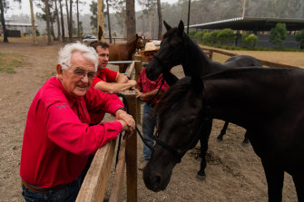
Willinga Park equine centre owner Terry Snow did not evacuate his premises on the NSW South Coast ahead of the bushfires in the region.Credit:James Brickwood

The Canberra-born billionaire saved the property. But the 77-year-old’s intricate fire plan has also been credited as part of the reason the nearby coastal town of Bawley Point escaped annihilation in the firestorm that swept through the region last month.

When the area was evacuated, Willinga Park took in the families of staff and the community’s horses, and scheduled a helicopter to fly in food and supplies.

Mr Snow believes the comprehensive planning, collaboration with the Rural Fire Service and their on-the-ground effort to establish a strong fire break saved the property. "When the fire came, it didn’t come onto the property because there was no flammable material at ground level so there was nothing to burn," he said. "You only have to compare us and the destroyed national park to see that it was a success."

Mr Snow said the park's preparedness meant the RFS was able to concentrate on other properties under threat in the area, but also provided protection to Bawley Point. "If we weren’t here as a barrier, the fire would have gone through Bawley and caused mayhem," he said. "We’re also very lucky that the fire department had a well-orchestrated defence ... and did such a wonderful job. None of us lost our houses and ... we didn’t lose a single animal."

Shoalhaven mayor Amanda Findley believes it was a combined effort, saying the "heroic" efforts of the RFS, Willinga Park’s "significant private firefighting capacity" and Bawley’s residents saved the town. "The resilience and spirit shown by that isolated town has been incredible," she said.

How defendable is Bawley Point
I have done a basic desktop analysis.

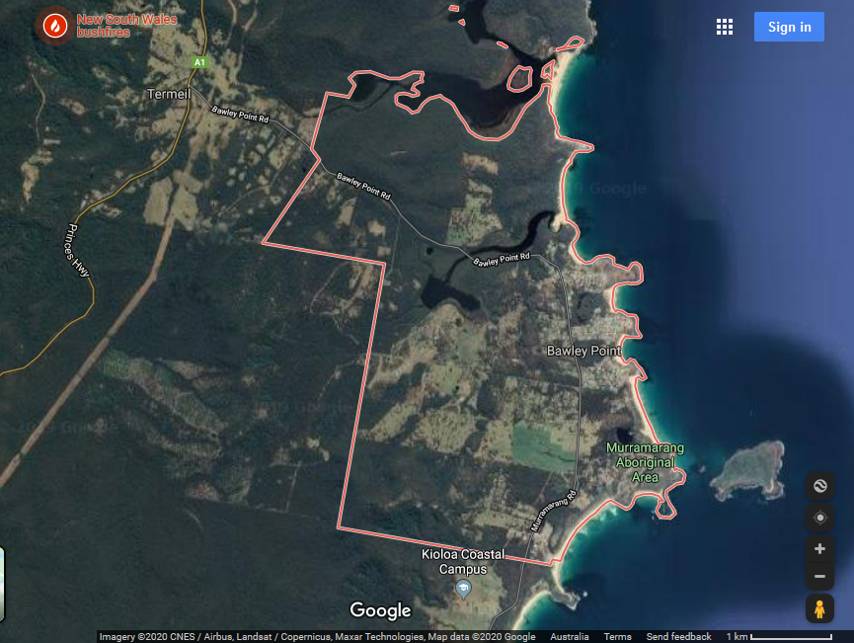
The fuel bed within some of the town is discontinuous, meaning there will be no running flame. However, the outskirts look like houses and sheds amongst continuous fuel bed, which is more concerning.

Willinga Park provides a substantial barrier to flame spread from the West and SW.
The massive block of forest that surrounds the settlement on the N, W and S will generate long lasting and heavy ember attack into the town in severe weather unless it has been recently fuel reduced. High density spot fire attack requires many self-defenders to extinguish spot fires while small. Therefore, evacuation here will exacerbate the damage toll because it removes potential spot fire extinguishers. Unrestrained spot fires here will wipe this town off the map in severe weather. I have been unable to ascertain weather severity or time of bushfire attack.

The fact that no houses were lost is evidence that they had created a safe workplace for self-defence by local brigade and residents, and that there was successful cooperation between local brigade and residents to stop spot fires while still small.

