Something strange about these NSW fires
10 November 2019

The NSW Fire agencies are giving out warnings about bushfires because of bad weather on Tuesday.
When are they going to give out protection to whole communities from bushfires?

The Victorian fire agencies are now scaring the public about bushfires
When are they going to stop scaring people and start protecting them and their houses?

The Victorian fire agencies say they must leave early because fires travel at 20 kph, according to the Minister.
When will they tell them the truth about evacuations and make it safe for them to stay put?

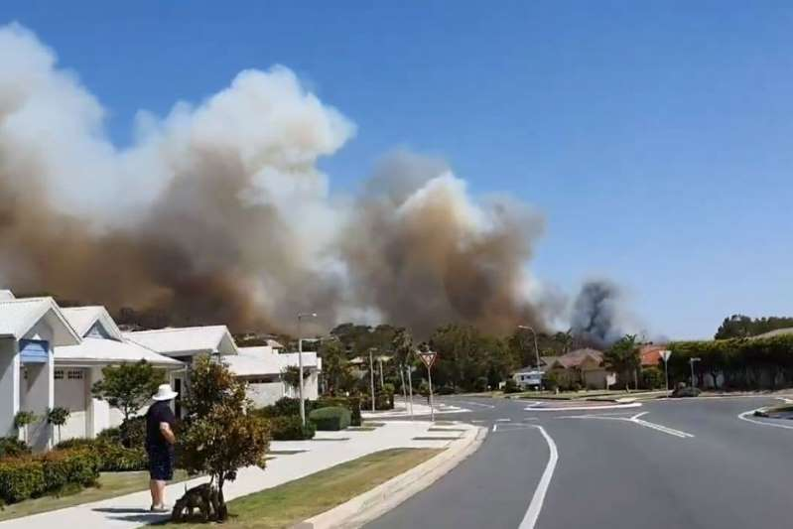© ABC News Residents of the beachfront town of Forster watched as smoke billowed on the horizon on Friday afternoon.

There is something strange about the fire agency response to these spring bushfires in NSW. They now want people to be better prepared and more alert for bushfires, but people pay for protection against bushfire damage. People know the best protection is best done by pre-planning and preseason prevention works, but the fire agencies only give them suppression response, evacuation and orders to be more alert. The people are therefore not getting what they pay for.

Today’s (Sunday 10 Nov, 2019) RFS announcements
CATASTROPHIC FIRE DANGER - Catastrophic fire danger now forecast for Greater Sydney and Greater Hunter areas on Tuesday. Large areas of state expected to see Severe or Extreme fire danger. Know what to do to reduce your risk.

STATEWIDE TOTAL BAN - A statewide total fire ban has been declared for Monday and Tuesday due to dangerous fire conditions across NSW

At 10:30am there are more than 70 fires, with half yet to be contained. While conditions have eased today, extensive fire activity will continue to challenge firefighters, ahead of worsening conditions on Tues. Monitor conditions & use the time now to get ready.

Tuesday 12 November will be a dangerous day. Widespread areas of Severe and Extreme fire danger. With so many fires already burning, homes and lives will be at risk. If you are threatened by fire, you may not get help. Start taking action now.

At 6:15am, 72 fires across NSW, 36 not under control. 11 fires remain at Watch and Act. Crews took advantage of easing conditions overnight conducting backburns to protect properties. They will continue to establish containment lines ahead of worsening conditions on Tuesday

Half the fires are not yet contained and it is one or two days till the next burst of hot dry winds, and they are asking the people to get ready. What on earth do they mean? People pay fire agencies to protect them. The fire agencies that allowed this dangerous situation to occur must be brought to account, not rewarded with a bottomless no-strings budget.

We hear they now have 70 current fires and they allocate 1400 fire fighters (Herald Sun 10/11) from their 74,000 members. That is only 20 firefighters per fire. That cannot be correct, surely. Some of these fires have huge perimeters. Half are supposedly contained, but their huge perimeters have to be blacked out for weeks. A freshly contained 20km fire perimeter should be patrolled by at least 400 fire fighters, even more in severe weather. No wonder they keep breaking their containment lines.

Something is not quite right here. This government of highly paid bureaucrats has expected a lot of these front-line troops since early September. Most of the fire fighters are unpaid volunteers.
Their employer has not seen them for a while, their own businesses are missing them, their families are missing them. The bureaucrats turned a blind eye to burn off’s during August and September, letting them grow in size, and now the volunteers are expected to fix the mess.

The people need help. They need to know how to self-defend properly because there are not enough fire fighters. They need to learn how to insulate their assets from these indifferent fire agencies. I fear Victoria has copied their ineffectiveness. Like NSW, Victoria has not prepared communities and people for self-defence. They rely on suppression and evacuation policies.

The fire agency policies have not dealt with the following phenomena:
- A regular annual dry season occurs in NE NSW each year, typically June to October, usually balmy weather with little rain.
- A regular natural event in NE NSW is that once or twice each month, strong winds from the hot dry inland sweep towards the coast and overrun the normal afternoon offshore air flow from cool sea to warm inland. [A common trigger is a strong cold front from the southern seas].
- A common theme about these fires is that they had been burning within insecure containment lines in balmy weather and when these strong hot dry winds revitalise their hot spots, they carry sparks into downwind dry forest fuel beds, which ignite fresh bushfires
- A common theme about these hot dry winds is that they are forecast with several days’ notice.
I have just examined three NSW bushfires to identify what policy and procedural errors allowed small fires to grow so large and destroy so many lives and houses and create so much unnecessary anxiety. See subsequent POSTS.
Delivering a catastrophic fire danger warning is a disappointing service to the tax payer. It should never have been allowed to get this bad. Let’s check the forecast for Taree to see if the weather warrants such a rating. Monday and Tuesday have been declared as state-wide Total Fire Bans. Normal trigger is a Forest FDI of 50+ for the 3pm weather forecast.

Taree’s 3pm forecast is
Monday - 26C, 42% RH and wind 26kph from East Calculated Forest FDI = 15
Tuesday - 37C, 16% RH and wind 26kph from NW Calculated Forest FDI = 45

These forecasts do not warrant TFB status in this area. This suggests Tuesday’s catastrophic declaration is not based on weather, but perhaps on potential destruction expected by the fire agency, presumably because of the large number of uncontained fires that have grown over the previous two months.

