Tanker flipped by tornado?

Denis O’Bryan
Red Eagle Bushfire Protection Services
8 January 2020

"We were on the flank of the fire, which is the safest spot to be. But when you are hit by a freak tornado, you can't calculate for that. It wasn't a dangerous situation but it became dangerous in a matter of seconds." Driver, Culcairn fire captain Andrew Godde

Wrong. We can calculate for that. Bushfire behaviour obeys the laws of physics. This incident was awful. We must learn “to calculate for that”. We must learn what really happened so that no more lives are lost nor injuries occur.

Please RFS and other fire agencies, do not dismiss this as a freak of nature or a climate change thing.

The ability to judge safe parts of a fire and impending danger is surely a lifesaving skill that fire fighters and residents in bushfire areas must learn.

Therefore, the Coroner should get the CSIRO or a McRae or a Sharples to study this incident to find out what went wrong and what can we all learn, whether it was a tornado or a whirlwind or a wind tunnel or a down burst or what.

What happened?
Piecing together media reports, including comments by the driver, it appears the police were notified at 5.50pm on Monday 30 December 2019 “a NSW Rural Fire Service truck with three men on board had rolled on a property at River Road”.

“It’s believed the two passengers were firefighting from the refuge area behind the main cabin when the vehicle rolled,” NSW Police said.

The truck’s driver aged 52 went to Holbrook Hospital. One passenger aged 28 died on scene. The other passenger aged 39 went to Alfred Hospital with serious burns.

There are reports of a second vehicle blown over and a fire fighter on board also transported to hospital.

"On that same fire, through the same weather event, we also saw another vehicle and a couple of firefighters enveloped by flames," Commissioner Fitzsimmons said.
He said two firefighters received face and airway burns.
One of them was sedated and both were flown to treatment at a Sydney hospital.

Is this the first or second vehicle?
news.com

Firstly, the truck driver statement

Culcairn fire captain Andrew Godde
"Unfortunately our truck was in the wrong place at the wrong time.
"It was a direct hit.
"To pick up an eight-tonne fire truck and throw it to the ground like a rag doll. It's a pretty wild force of nature.
"We were on the flank of the fire, which is the safest spot to be. But when you are hit by a freak tornado, you can't calculate for that.
"It wasn't a dangerous situation but it became dangerous in a matter of seconds."

Then the commentary from the RFS hierarchy.

Commissioner Fitzsimmons
ABC on line reports: Rural Fire Service commissioner Shane Fitzsimmons on Tuesday said: "Crews described what they experienced as truly horrific, an extraordinary wind event, describing it as a fire tornado or the collapse of a pyro-convective column that had formed above the main fire front.

News.com reports: The accident that killed Mr McPaul and injured three of his colleagues was the result of an “extraordinary wind event, a fire tornado, or a collapse they believe might have been a collapse of pyro-convective column that had formed above the fire front,” Mr Fitzsimmons said.
“That’s resulted in cyclonic-type winds that has moved across the fire grounds and has literally lifted up a 10 or 12-tonne fire truck and lifted up its roof, tragically killing Sam in the process.”

Superintendent Westwood
ABC on line reports: Superintendent Westwood said the fire had "created its own weather system, "known as a pyrocumulus cloud”, leading up to the incident.
"That cloud became very unstable," he said.
"It had a height of around about 8,000 metres and unfortunately, it appears to have collapsed during yesterday's deteriorating weather, causing erratic fire behaviour and erratic winds at the foot of the fire in all directions."
"The crew decided to move away from that area and, quite unexpectedly, very suddenly, they experienced extreme winds and what could only be described as a fire tornado that lifted the back of the truck, fully inverted it and landed it on its roof, trapping three people,

In summary
We have the announcement of a suspected fire-filled tornado flipping over two trucks and engulfing fire fighters with flame, causing 1 death and 4 injuries and two wrecked vehicles in a section of the fire that these experienced firefighters thought was safe.

Comments:
This is a very serious incident. Please RFS and other fire agencies, do not dismiss this as a freak of nature or a climate change thing. Find out what went wrong and what can we all learn.
The ability to judge safe parts of a fire and impending danger is surely a lifesaving skill that fire fighters and residents in bushfire areas must learn.

To my mind, the official commentaries do not seem quite right or do not match known science. We need to know what really happened. It is misleading and simplistic for authorities to state that the fire creates its own weather, and it is too easy to use it as an excuse for a failure or a non-action. All fire behaviour follows the laws of science, and is therefore predictable and explainable. I have made great efforts to discover these laws and to apply them. I wish the fire agencies would also.

There is a good bit of science known about pyro convective columns.
- If the fire’s size and heat leads to a tall convection column, the atmosphere is already unstable but the column per se has no influence on the source fire. It may generate lightning but that is delivered many km downwind. If the 8,000m convection column develops in the calmer morning skies, it might send downbursts of cold air to ground as in a thunderstorm. If it is hit by a strong NNW wind, it would be pushed on a lean, rather than collapse suddenly. If heat created it, the heat will intensify with the stronger wind and sent more heat aloft. To my knowledge, it does not just collapse and send down ferocious winds.
- In a running fire, the convective phase occurs frequently during a fire’s run, alternating with the wind driven phase. When the convection phase is strong, flames are tall and embers rise high into the atmosphere and the fire’s rate of spread slows. When they collapse, flames are low, wind flattens them along the ground and rate of spread is faster. There are no tornadoes in this mix.

We know that fire fronts can generate large whirlwinds that can leave the fire and run independently of it. If this happened, it would not be flame-filled.
We know that two parallel fires can create a whirlwind flame in between. Is this what happened?

We know that an area of unburnt fuel between two tongues of flame can suddenly become fire-filled. This can happen very fast.

There is a good bit of science known about formation of tornadoes. Albury’s weather at the time was 41C, 7% RH and wind 35 kph from NNW. Not a precursor of tornadoes. But air pressure had dropped to 1006 hPa since morning. Maybe that was a precursor? The front itself did not cross the fire ground until 5am next morning.

There is a good bit of science around regarding vehicles being pushed or moved by tornadoes. There is the Fujita scale and subsequent variations. McRae reported a trailer being lifted by an F2 fire-tornado in Canberra, but not the tanker that was towing it. Was this an F3 or F4 tornado?

Can an F2 tornado occur at a fire that has not been going very long?
Is there on-site evidence of tornado damage?
Were the storm clouds low at the time with vortices dropping down below them?
The Weather Bureau will surely have corroborating evidence.

Other pertinent questions include:
Did the truck flip or did it roll?
What uplift air speed is required to lift up the truck?
What wind speed is required to push the truck over? Or was it already on an angle?
Where did it happen?
Were they too close to upwind flammable vegetation?
Was there a local wind tunnel?
Was there a local change of wind?

Here is the probable site of the incident (yellow outline is River Road along Murray River)
Red dash line is estimated maximum extent of fire at time of incident.

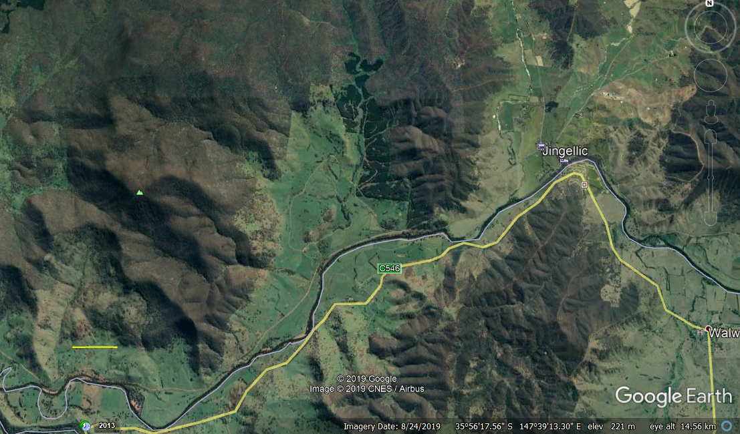
1 km

Here is the weather chart showing the site of the incident (red circle)

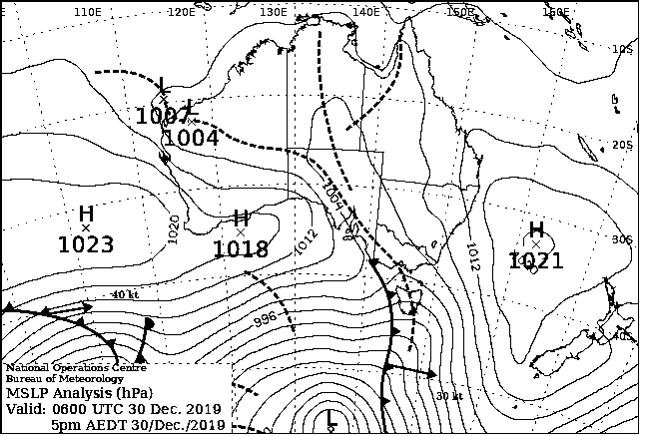

Here is the fire’s approx location at the time of incident (red) and on the following day (blue), after its run.

