Meanwhile, what is going on in Victoria?
Denis O’Bryan, Red Eagle Bushfire Protection Services, 29 Dec 2019
(1) Fire agencies are presenting Far East Gippsland with a potential 50 km fire front tomorrow, courtesy the Snowy River bushfire. The condition of its SE perimeter is a mystery, but based on vehicle allocations, they are letting it run rather than aggressively suppressing it.

Information is scarce. Regular Tweets like the RFS gives out would be useful.
Has the “suppression-when-small policy” in National Parks gone missing since the Noughties? We don’t want National Parks in drought years here and in NSW to become known as sources of potential destruction of adjacent properties by hellfire, do we?
Perhaps people will gradually realise that self-defence is an essential tool for their property’s management when they understand that fire agencies cannot or will not suppress these fires.

The Snowy River National Park bushfire has now been running for over a month and only the eastern end is growing.

Is history about to repeat tomorrow? 2003, 2014, now 2019? Probably not, if its expansion on 20 Dec is a guideline. Luckily, much is high elevation plateau / tall tree country.
There was even an inquiry after the 2014 one. Let’s hope Goongerah has been protected since then. Let’s hope Orbost has been protected. Otherwise learnings may not be hitting the mark.

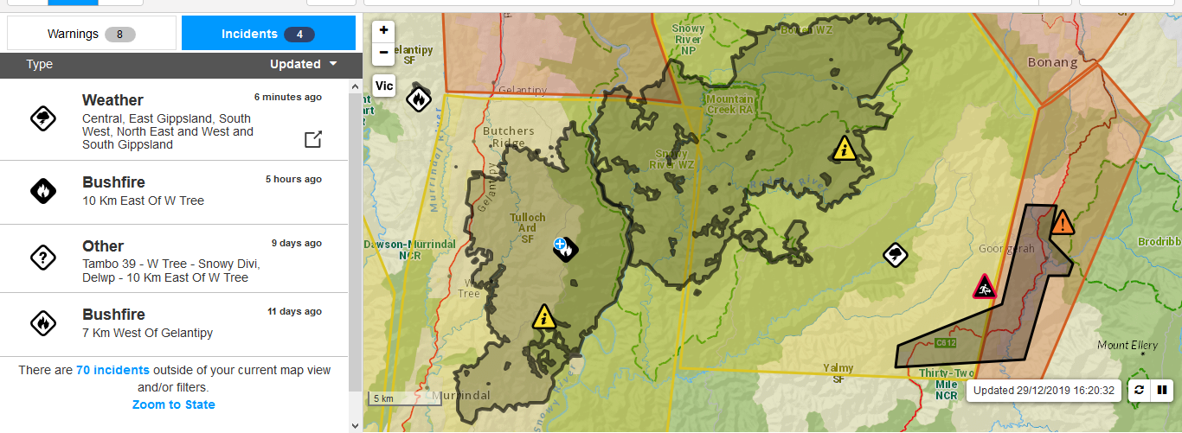

Let’s overlay this fire area approximately onto this fire history map FYI: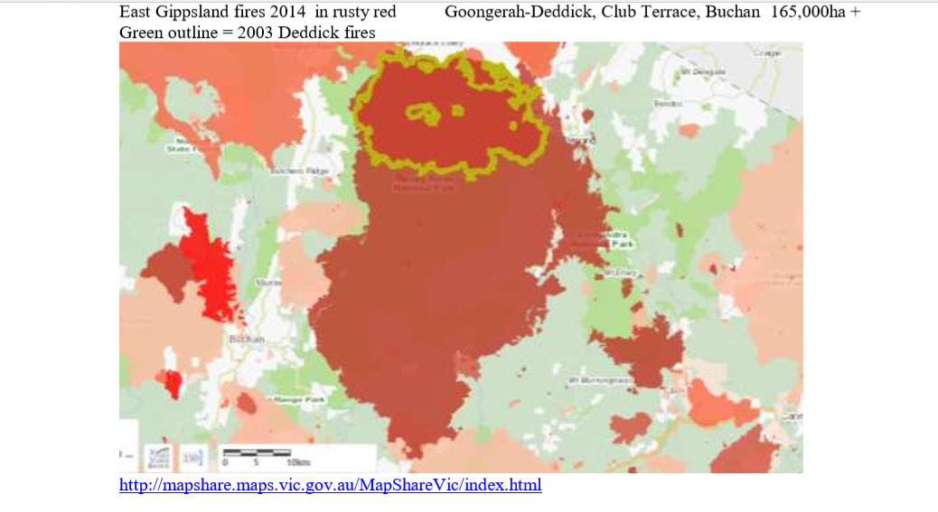

(2) The official request to evacuate on a non-TFB day is controversial.

A moderate NE then NW wind is forecast tomorrow. A Total Fire Ban is NOT forecast for East Gippsland, but on the TV they are asking 30,000 visitors to leave East Gippsland now, whereas the on-line print media are saying everyone must leave. It seems a bit extreme, as does the Falls Festival cancellation in the Otways, where there are no current bushfires. We can make any area bushfire-protected. If the threat of bushfires leads authorities to kick people out of rural areas, we suggest they use their huge budgets to make the bush safer.

BOM forecast for Monday 30 December Winds north to north easterly 15 to 20 km/h tending north to north westerly 25 to 35 km/h during the morning. Overnight temperatures falling to between 16 and 23 with daytime temperatures reaching 34 to 42.

Weather.com forecasts 20% RH and 38C and 34 kph winds, which puts the FDI just above 50, which was the trigger for a TFB. If they are so worried about their fires, why did they not declare a TFB? We will keep an eye on the weather.

The official request to evacuate on a non-TFB day is controversial. It is difficult to justify on the basis of the weather forecast and it implies absolutely no confidence by officials in the normal advice about go to a safe place, or stay inside – it is too late to leave, etc. If visitors and locals cannot be safe in E G towns, our fire agencies have failed us all. I would be very comfortable to stay put.

The official reason was concern that the Princess Highway could be cut off for a few days, and people would be forced to stay in E G longer. Why is that so bad? So much for the E G economy in the middle of future fire seasons. If the Princess Hwy cannot be held open for normal travel and commerce in summer, our fire agencies have failed us all. I would be very comfortable to stay put.

The performance of the four troublesome fires over the past fortnight does not justify the request to evacuate. The testing day was 20 December:
- The Barmouth Spur fire had 16 vehicles allocated to 9.500ha. It expanded SE to 50,000 ha, running smack into the Bruthen fire. It has since expanded to 78,000 ha due to burning-out consolidations.
- The Bruthen fire stayed at 10,000 ha and has not grown since.
- The Ensay fire was virtually unaffected 19,000 to 20,000ha and has not grown since
- The Snowy River fire grew from 18,000 to 27,000 ha. It has since grown organically to 33,000ha, mainly in the eastern end.

I am not sure where the Princes Hwy will be cut off for a few days.
Here is what we know so far:

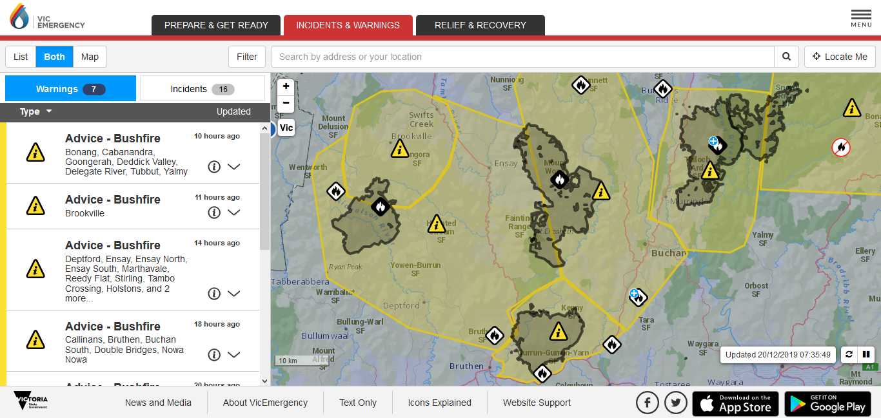

20 Dec AM Barmouth spur Ensay Bruthen Snowy R N P
9,400 ha 19,000 ha 10,000 approx 19,600 ha
24 vehicles were on the Snowy fire. Perimeter approx 100km.
If vehicle allocations reflect concern levels of the authorities, this is hardly a committed response on a severe weather day, is it?
If all are on danger side, this is an average of 2 vehicles per 4 km.
By comparison, The Ensay fire had 50 vehicles for similar perimeter.
Or maybe these figures are spurious?

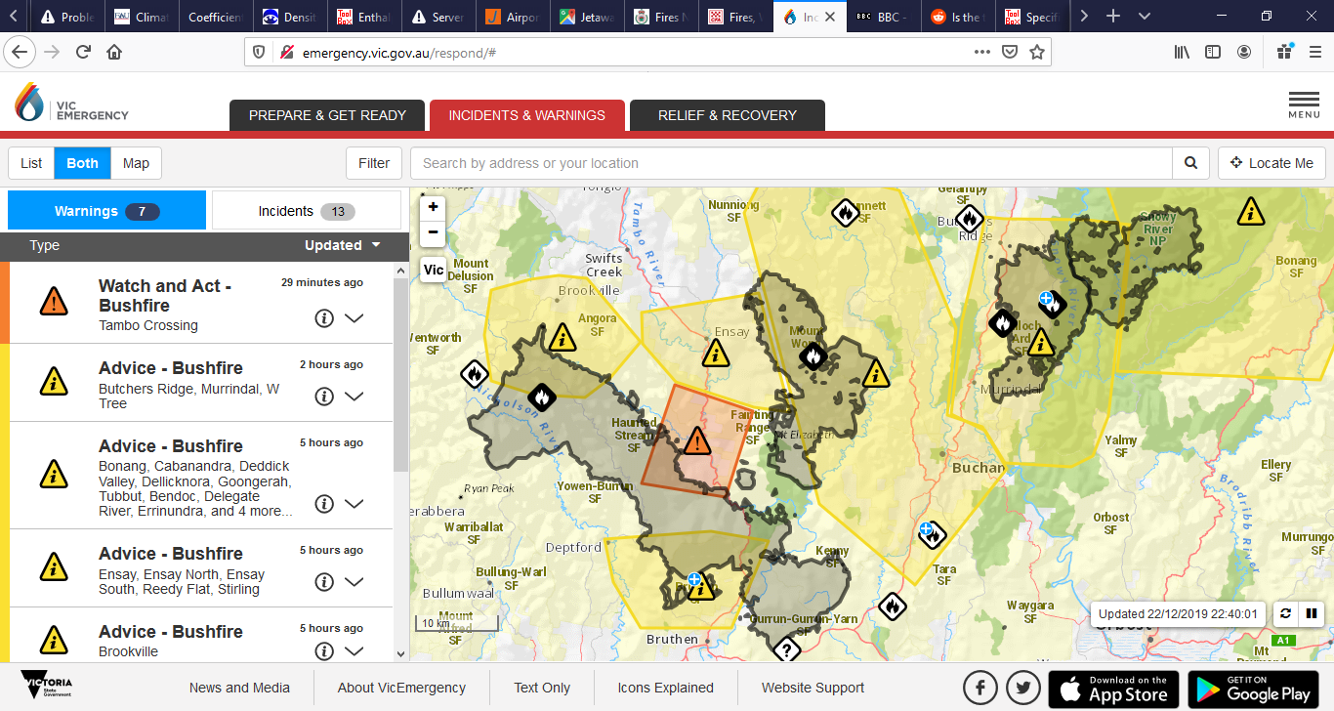

22 Dec Barmouth spur Ensay Bruthen Snowy R N P 51,900 ha 20,000 ha 10,000 approx 27,600 ha
12 vehicles on the Snowy fire. Perimeter is well over 100km. Ensay had 74 vehicles. Barmouth had 31 vehicles.

The Barmouth and Bruthen fires may well have been amalgamated. Information is scarce in Victoria. The 10,000 ha may have been added to the 65,900 ha to get to 78,000.

26 Dec Barmouth spur Ensay Bruthen Snowy R N P 65,900 ha 20,000 ha 10,000 approx 31,000 ha
20 vehicles today on the Snowy fire. Perimeter is well over 100km

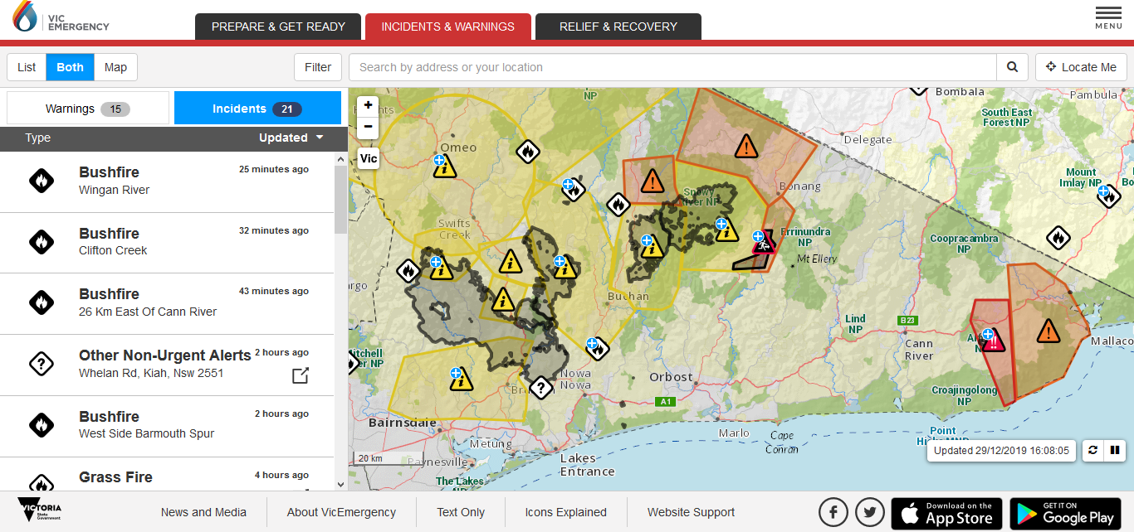

29 Dec Barmouth spur Ensay Bruthen Snowy R N P 78,300 ha 20,000 ha 10,000 approx 33,700 ha
22 vehicles today on the Snowy fire. Perimeter is well over 100km. Ensay had 18 vehicles. Barmouth had 31 vehicles.

