Why was Mallacoota not bushfire-protected?

Denis O’Bryan
Red Eagle Bushfire Protection Services
31 December 2019

Mallacoota does not deserve this punishment – being attacked by a 15km bushfire front. This is a very sad outcome. House loss is avoidable, but the right preparations and works-on-ground have to be done beforehand. Without them, firefighter lives are at risk, the lives and possessions of 4,000 people currently anxious on the beach are at risk because of the government’s unenlightened approach to bushfire management and land management. Moreover, 70,000 ha of forest fauna and their habitat has now been wiped out at once. This is abysmal crown land management. The government has dropped the ball on real bushfire protection by adopting the “bushfire protection by media spin” approach - “We have never been better prepared” – Prepared for what … is not defined; “We know fire”. No they don’t. Empty but clever words do not protect people and their houses.

In this weird era of government management of crown land and of the bushfire threat, we now ask this question each summer - which town or towns will be wiped out this fire season by the random lotto of the escaped bushfire? The need for people-powered self-defence by residents and towns has never been more acute. I really hope Mallacoota residents have done enough to protect their houses in spite of their $600+ annual fire levy for which they see no return except empty words. Towns are protected by protection works on the ground in the right areas.

What has happened in the last few days is the consequence of years of neglect of the bushfire threat in the National Park, which in this area is tantamount to malpractice by fire agencies and the land manager. It is now inflicting destruction onto its neighbouring residents and onto the fauna and the habitat it is supposed to be managing. It is evidence of the inability of our well-funded fire authorities to protect the people and houses of Victoria from bushfires - they have focused on suppression of going fires at the expense of protecting towns. It is evidence of appalling crown land management - the National Park has been allowed to become an inferno.

The fire on the Wingan River came to our attention two days ago when it was 40 ha = approx 1000 x 400m, running to the west under a light wind. The single vehicle response appears so irresponsibly low that it must be a typing mistake, surely.

Suppression when 40 ha failed for whatever reason, and a day later, the fire has grown to 22,000 ha, stopping at the coast, 20km distant. Six vehicles on a 22,000ha fire must be a typo, surely.

The SW change arrived at 6.30 this morning, blowing with a vengeance between 8 and 10am between 35 and 45 kph. The eastern flank became a vigorous 15+km front, arriving at Mallacoota’s doorstep at 10.30 am. It travelled 30km in approx four hours, = 8 kph. This pace is consistent with substantial heath vegetation and considerable short-distance ember assistance.

Six vehicles on 72,000 ha must be a typo, surely.

How has Mallacoota been protected by works-on-the-ground in recent years?

Planned burns?
A useful area was burnt in 2013. Probably not so protective now.

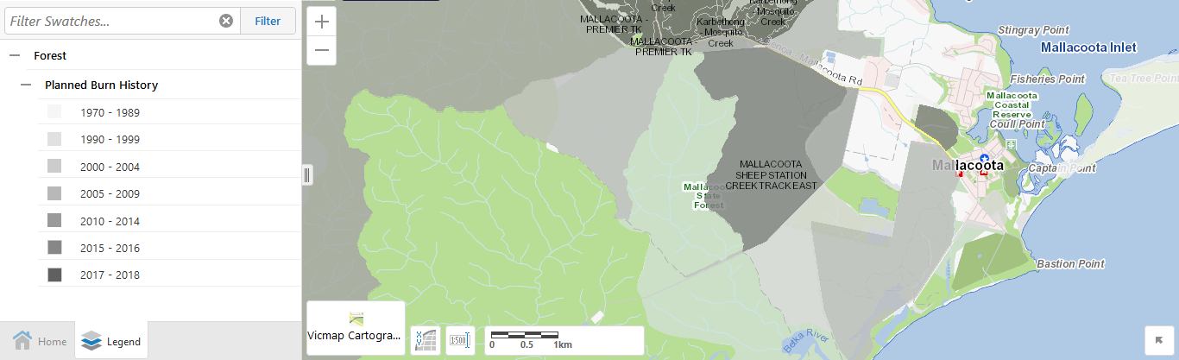

The large grey area was burnt in 2010. A bit too far from Mallacoota and a bit too old to be protective now.
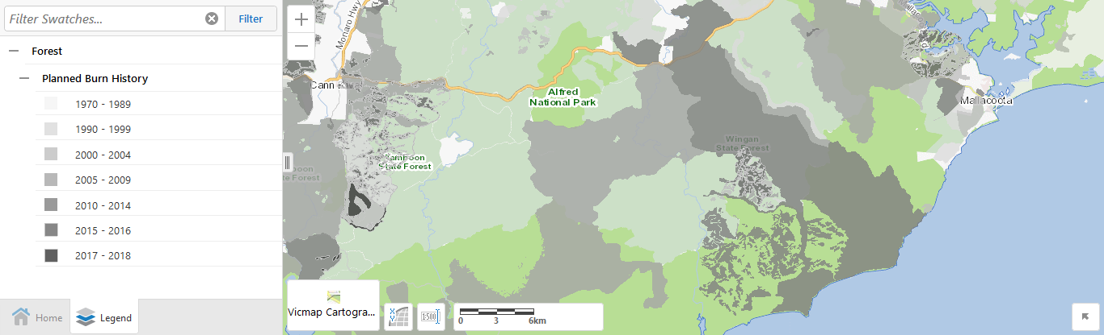
Red line is fire at 10am this morning. Blue line is fire yesterday.

Recent bushfires?
Little has been burnt in recent times to be of protective benefit.
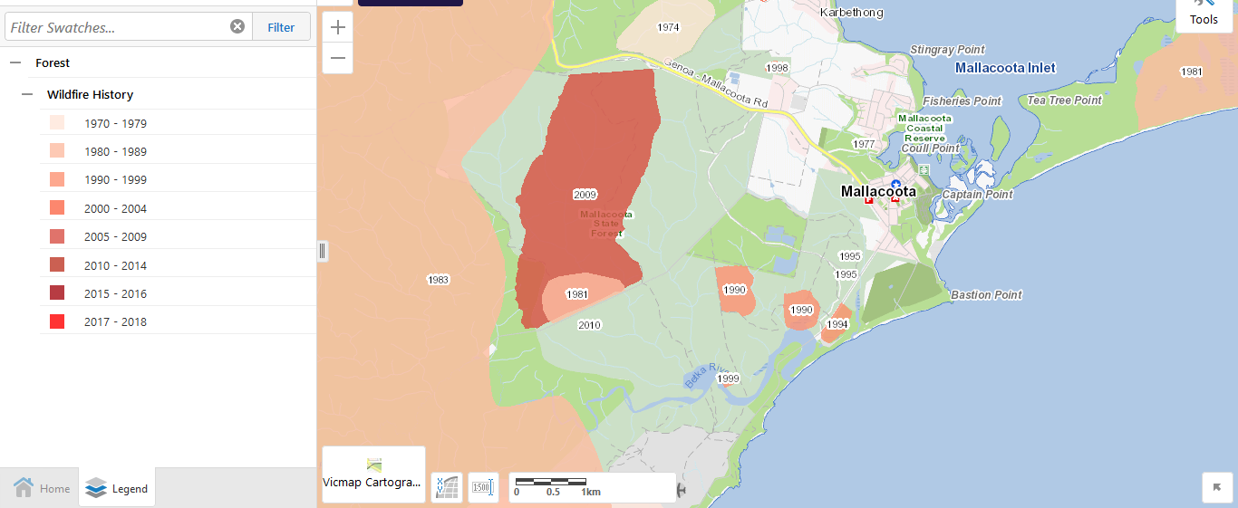

What other protection works were done on the ground to prevent flame approach and flame spread or to reduce flame height?

What empowerment of people was delivered to deal with ember attack and spot fires while still small?

There should be a zero house-loss goal for each town to guide these works and empowerments. But I do not see evidence of this enlightened approach yet. When we protect the house, we protect the life.

If the government cannot or will not bushfire-protect a town, self-defence or good luck or people power like our forebears practiced might be our only hope. But is this what we pay our taxes and fire levy for now?

Towns are protected by proper preparations beforehand, not by hasty or futile suppression efforts against an inferno on the doorstep and sympathy statements and handouts after the destruction.
It is time for panic and fear and distress to be replaced by good process and orderly governance.

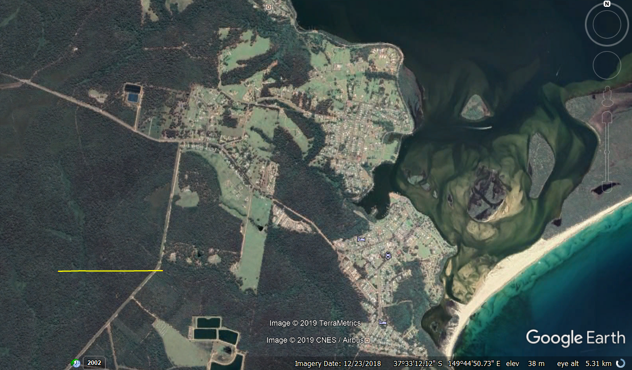

Meanwhile, the unrestrained fire progresses towards NSW.

